**Solid Waste Management**

San Carlos City, Negros Occidental

Philippines

The problem in solid waste and its management has become a genuine concern of the City of San Carlos. The rapidly swelling population, increasing urbanization and intensifying economic activities have all contributed to the generation of solid waste. In response to this problem, the Local Government Unit of San Carlos City has adopted measures to anticipate the expansion of solid waste management services, provision of a more cost-effective garbage collection and hauling, development and implementation of innovative solid waste disposal practice.

San Carlos City collects 17 tons of solid waste daily at an average generation rate of 0.50 kg per person per day in the urban center. Like in most local government units, the city was also confronted with the complex problem of increasing waste generation and solid waste disposal. The problem affected the LGU five folds: demand for compliance to the new Solid Waste Management Act – RA 9003, availability of landfill site, waste disposal costs, budget for implementation and the most compelling reason of adverse environmental impacts from solid waste disposal practices and continuous operation of an untidy, open waste dump. Then, there was also the concern of finding a good strategy to introduce the program objectively to an often apprehensive community. The local leaders boldly decided to implement an “integrated waste management solution” adapted to fit the community’s needs and constraints, even as they were willing to question assumptions and assertions on all sides of the issue.

The Local Government of San Carlos went beyond the conventional solid waste management program of using an efficient collection system and infrastructure. Instead, it embarked on a comprehensive education and advocacy that sought to change people’s behavior towards responsible waste management. While information, education and communication is enunciated in R.A. 9003, the Behavioral Change Approach is based on an education platform that enables the target audience to learn the positive or negative consequences of their action. It further focuses on the benefits derived from positive waste management practice thus leading to individual and group motivation.

In 2007, the city then established an Eco-Center which is an integrated facility for handling waste. The facility includes a building that serves as the central materials recovery facility (MRF) for final processing of waste, an office, a motor pool, a mechanical-biological treatment/windrow composting area and a 2 hectare clay lined sanitary landfill facility for residual waste. The MRF operation is a unique innovation, which utilizes gravity force to slide down the recyclables to segregation bins during final waste processing.

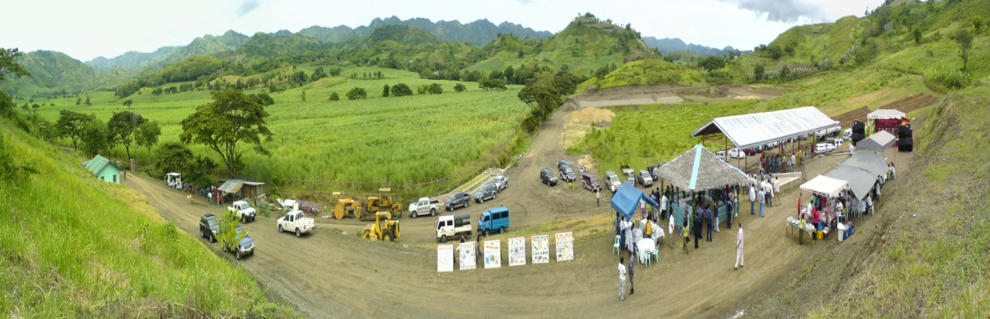

Panoramic View of the Eco-Center

With all the programs and facilities functioning, out of the 17 tons per day collection, the city is now able to divert 11.9 tons of waste (70%) as recyclables and compostables. Out of this fraction, 8 tons of waste is composted. In 2011, the composting capacity was improved from 0.5 ton to 2 tons compost production per day. Likewise, 0.1 ton of light density plastic has been recovered for potential co-processing as Alternative Fuel and Raw Material (AFR) in cement kiln in the future. About 5 tons of waste per day is left as residuals for disposal at the Eco-Center’s sanitary landfill. ***This significantly reduces the amount of greenhouse gases emitted in the atmosphere and at the same time prolonging the lifespan of the sanitary landfill. (See figures below).***



Results of Greenhouse Gas Emissions and Disposal in t CO2-eq/yr

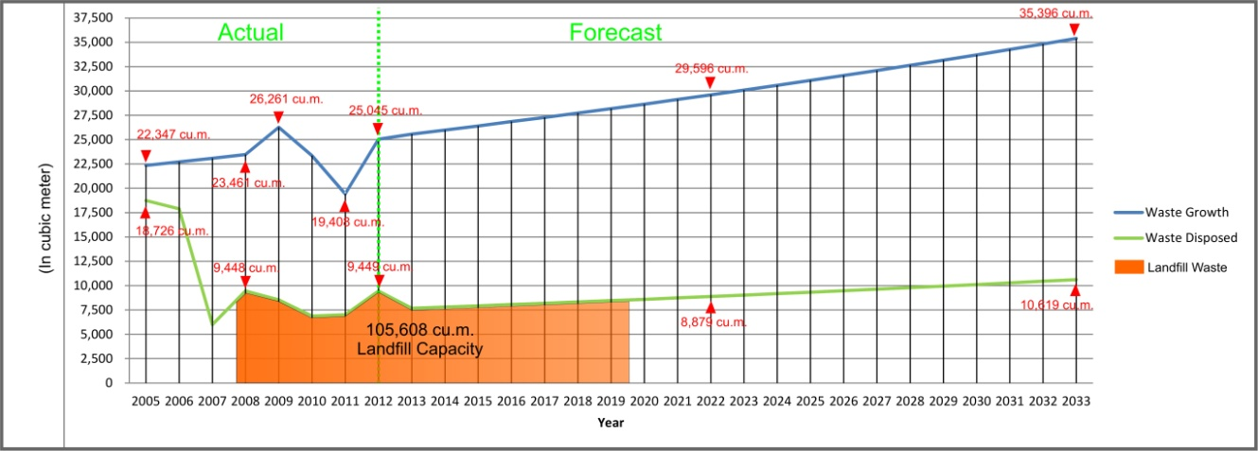

Projected Landfill Lifespan (using 70% waste diversion)

Regression analysis helps forecast future waste disposal. Factoring waste generation growth rate at 1.64%, San Carlos City will dispose of approximately 16,865 tons or 96,376 cu.m. in 10 years, 26,385 tons or 150,772 cu.m. in 15 years and 36,711 tons or 209,778 cu.m. in 20 years, with an estimated population of 160,000 in 2032. The implication of this trend is that demand for landfill space will increase with time as population grows and that per capita waste generation will continue the long term increase despite the decrease in year 2011.

To date, San Carlos City is proud to say that the city is clean with no litters on the street. The Eco-Center is gaining impacts as it contributes to provide a safe and environmentally-sound processing and disposal of household waste to its 133,000 residents. Significantly, the Eco-Center has now become a learning ground and showcase of good SWM practices and environmental governance. Besides, the desired increase waste diversion rate could already be implemented to more than 70%, which by far surpasses the legal prescription of RA 9003 which is 25%. Since the opening of the facility, more than 6,000 visitors from neighboring LGU’s, students and professionals in the Visayas, from national and other regions, as well as from other countries (Indonesia, Germany, USA and Bolivia) have already signed the guestbook. Similarly, the expertise of the trained key SWM managers of San Carlos City are also requested by other Local Government Units (LGU’s) in the country to provide assistance in the replication of their good practices. And, the city’s unique MRF was already replicated several times by other LGU’s, a proof of the city’s valuable efforts.

San Carlos City is a quiet city that has taken a great leap towards excellence in governance and public service, idealistic environment and heightened economic activities. A Hall of Famer in the prestigious National Galing Pook (Best city) Awards for outstanding public service programs and a regional Excell (Excellence in Local Governance) Awards champion , the city is moving forward with sure steps in pursuit of its vision of coming an exemplary modern agro-industrial city following a holistic master development plan.

From its achievements and awards are lessons shared with others who come to emulate its successful fiscal management, socio economic and environmental development programs, and effective and efficient governance that are focused on the city’s resources and felt needs of its people.