Low-Carbon & Energy-Saving Buildings
Promote a concept of Low-Carbon and Energy-Saving Building, or named Green Building. Tainan City Government is going to design a new principle for urban design, demonstrating the establishment of Energy-Saving Building and old building renewal.
- New buildings for Non-Public: Qualified Green Construction
- New buildings for Non-Public: Silver award
- Build rain storage system
- Grade of green buildings: 11 diamond awards,2 gold awards, 1 silver award, 7 copper awards, and 48 others
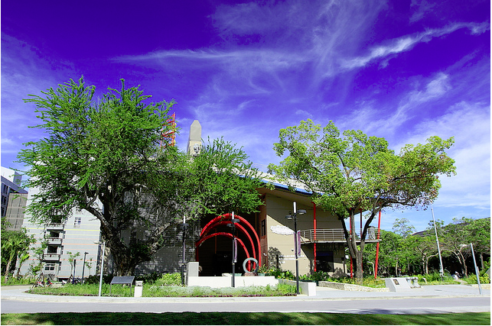
NCKU Magic School of Green Technology/ Certificate of the LEED by the USGBC

