Low-Carbon Communities
Promote and plan the Land Consolidation (taking an existing community as demonstration). Establish new green community systems and modify the old existing communities.
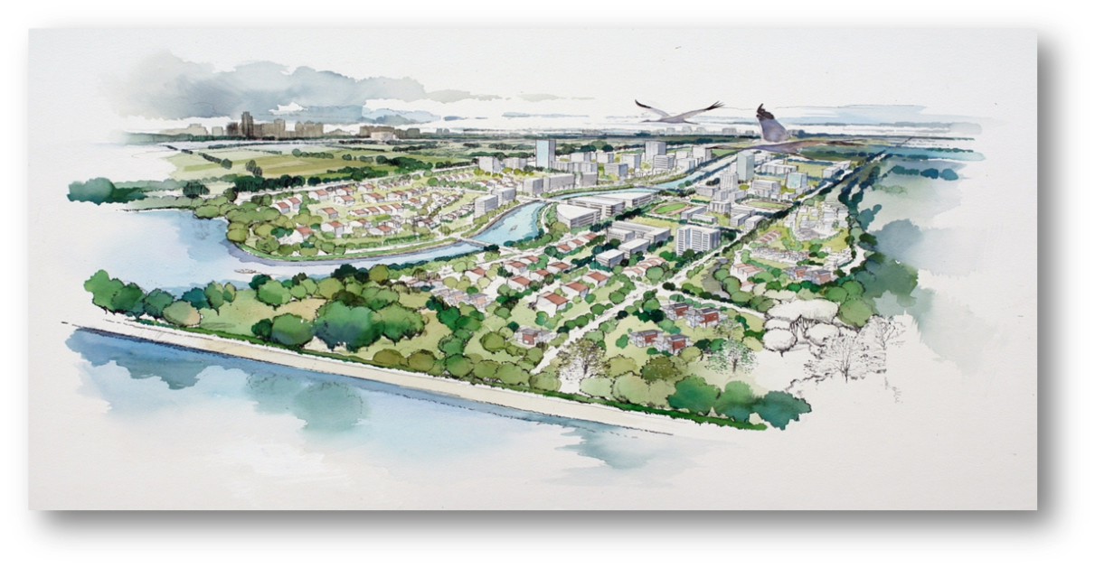
Public area and Environment:
- Permeable area: 70%
- Green coverage: 60%
- Reuse constructed waste
- Energy conservation & carbon reduction design
- Set LED for landscape
- Solar-power and smart streetlamp monitored system
- Solar panel on the pavilions for the emergency lighting

