Panaji: A Journey towards Successful Waste Segregation Leading to a No- Landfill City

Panaji, the capital of Goa, is one of the most popular international tourist destinations in India. The city is also known for its strong cultural heritage. Being a popular tourist hot-spot, the city usually witnesses more than a lakh 25000 tourists during prime seasons. The large influx of tourist population also leads to huge amount of waste generation which usually consist of multi-layered packaging (tetrapak), PET bottles, plastics, rubber and other recyclables with a high embodied energy.

Till early 1990s, municipal solid waste management in the city was restricted to collection of mixed waste and subsequent dumping of waste at the landfill located in Baingani. Asynchronous waste management activities resulted in an inefficient system with poor infrastructure resulting in unhygienic civic conditions. During intense spells of rain the mountain of waste in the dump site slipped and inundated downstream residential areas, resulting in massive public protests against dumping of waste anywhere within the city boundary.

Innovative leadership by the Commissioner of Panaji resulted in the campaign “Bin Free in 2003”, as an initiative to improve municipal solid waste management system in the city. The key elements of the program were:

* Door to door collection of segregated waste (dry waste and wet waste) for the entire city of Panaji along with the introduction of service charges
* Substitution of community bins by trolley bins along with automated truck-loading systems
* Program for recycling of all recyclable waste and composting organic waste.

The Corporation involved volunteers and local leaders to create awareness regarding segregation of waste at the household level. Trained volunteers; predominantly school/ college students visited individual households to practically demonstrate waste segregation. To begin with, green and black coloured bins were sold to households at subsidized rates. The households were sensitized towards importance of segregating kitchen waste from other waste. Green bins are used for wet waste and black bins are used for dry waste. The bins came with a screw system which reduced the chances of tipping over by stray dogs and cats. These bins were specifically designed for use in Panaji. Due to public interest generated and given the situation where the city had no other solution for waste management, both the community and political leaders supported the initiatives of the Municipal Corporation of Panaji.

Subsequently, to tackle the issue of mixed dry waste, the Corporation also implemented the “four bin system” in housing colonies. The bins are colour coded for easy segregation of dry waste.

* Grey bins for glass and metal waste
* Brown bins for paper and cartons
* Orange bins for plastic waste, and
* Purple for non- recyclable items like thermocol, ceramic, batteries etc

Microsoft Word - CCP - SAS for Restaurants.pdf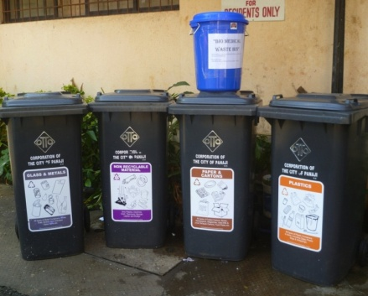

Waste generated from hotels and restaurants is segregated into five bins:

* Green bin for wet waste
* White/ translucent bins for plastic waste
* Black bins for plastic waste
* Pink bins for metals/ glass
* Brown/ Orange bins for non- recyclables

Housing societies have employed workers to collect waste from households. The biomedical waste consisting of cotton swabs, soiled diapers and sanitary napkins is collected separately from the houses in yellow coloured bags and transferred to the municipal vans for scientific disposal.