Climate-smart actions and consumption
Climate Smart Communication in the City of Stockholm
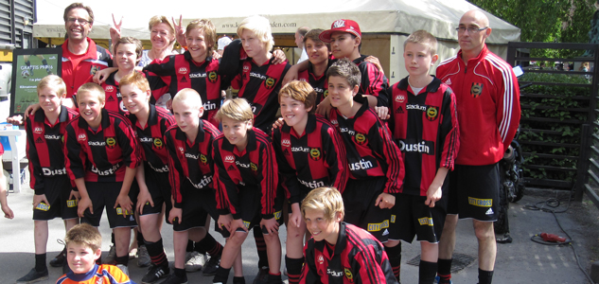
The City of Stockholm has for a long time initiated innovative communication tools to enhance the citizens understanding and adoption of climate-smart actions in the city.
Based on the growing knowledge and new statistics addressing sustainable consumption and global warming the City of Stockholm develops new campaigns and networking activities to increase the citizen´s involvement and interest through eye-opening communication activities.
We believe a wide range of tools for different target groups are needed. We also believe cooperation and networking with a variety of stakeholders is necessary to find new solutions.

The Discover Stockholm app
With Discover Stockholm, the City of Stockholm´s first app, stockholmers can easily find their way to all the local outdoor activities provided by the city such as playgrounds, sports facilities, beaches, climbing, natural areas and many more. The app also shows the users how to get to these places from the current location by walking or by using public transport through Google Transit. The app encourages stockholmers to discover and consume the city´s local places and services. Many of the city’s administrations cooperate to gather information about these activities. The app was launched for both iPhone and Android in April, 2011. In February 2013, the app had been downloaded almost 100,000 times. The cost to develop and update the Discover Stockholm app twice a year has so far been 1 000 000 SEK, with 600 000 SEK from external funding (Klimp). www.stockholm.se/upptackstockholm

The Climate Match
During May 2010, 19 football teams from the club Brommapojkarna competed in getting to practice and home matches as climate smart as possible. The team that was the best at walking, biking or riding public transport won a place in the Gothia Cup tournament.
– It’s good that players, coaches and parents are made aware of the environmental work of the city and get food for thought for the future, says Ola Danhard, club manager of Brommapojkarna.
The competition was repeated in September 2013 with 19 other sport teams in soccer, basketball, hockey and handball. www.stockholm.se/klimatmatchen

Climate Smart To Practice
The journeys stockholmers make in their leisure time are often made by car. This campaign motivated the inhabitants of Stockholm to walk, bike or travel by public transport to their sports facilities. Ads were placed in a local newspaper and posters were put up in the subway and in parking areas at the city’s sports facilities. In connection with the campaign, a joint project was initiated with the Sports Administration to inform people about how to get to the city’s sports facilities by bike or public transport.
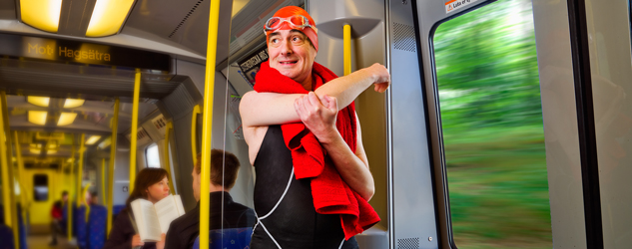

One Tonne Life
An average Swede generates around ten tonnes of carbon dioxide emissions every year. Is it possible to reduce carbon dioxide emissions to one tonne per person and year? A Stockholm family accepted the challenge and moved into the One Tonne Life house in January 2011. They had help from an energy-smart house, an electric car and a panel of experts. Emissions from all their everyday activities were monitored. The family could follow the energy use of the house in real time. In the end after six months the family achieved 1.5 tonnes per person. The largest part of their reduction came from transports and living arrangements. The project was initiated by Vattenfall and carried out in cooperation with Chalmers University of Technology in Gothenburg, Volvo, ICA, A-hus and Siemens. http://onetonnelife.com

The Climate Scale
The City of Stockholm has developed its own pedagogical consumption and greenhouse gas tool. You get a shopping basket and fill it with everything you normally consume during one day. Products and services are represented by colourful bags of different weight depending on their impact on the climate. Weighing your basket on the Climate Scale, you get an indication of the climate impact of your total consumption, and which parts of it are the largest. You can compare yourself to an average Swede, who emits roughly ten tonnes of carbon dioxide every year, and to the emission level that is considered sustainable in 2050. The Climate Scale lead to interesting discussions about which emissions we are able to influence and which need to be reduced by for example business or society. New insights give opportunities to make climate-smart choices. The Climate Scale has by now been tested by more than 5,000 persons. The design of the Climate Scale leads to creative and in-depth discussions. It can be booked and used in connection with lectures, seminars, festivals or for internal energy and climate education. It makes the national environmental statistics come alive and used in practice.

Sustainable Hökarängen
One of the City of Stockholm`s housing companies, Stockholmshem, has initiated a regeneration project in Hökarängen, an old city district built in the 1950´s, together with its habitants, shop owners, craft makers and local organisations. This has made it possible to gently renovate the housing, create small gardens, pleasant sitting and playing areas as well as increase the kind of services in the commercial area that the inhabitants have asked for. Along with increasing the social and architectural attractiveness of the area Stockholmshem has also used energy and resource efficient housing and waste technologies and invited sustainable services and products. In 2012 they also initiated a sustainable consumption project where the inhabitants are invited to suggest ideas and get support for how they can reduce their energy and resource use. The projects are made in cooperation with SUST (Sustainable Innovation AB) and funded by the Swedish Energy Agency. The project will end 2014.
http://hallbarahokarangen.com

The Climate Smart At Home and Climate Smart At the Office handbooks
The handbook “Climate-smart at home” contains short, simple and practical advice on how to reduce your climate impact in every room at home - in your kitchen, the bathroom, the living room and more. The handbook was distributed to all households in Stockholm. A similar handbook for local businesses working in an office contains similar advice on how to reduce the climate impact while saving time and money and become a more green business.

Consume Smarter
The family members in 40 households saved all their receipts in order to calculate their emissions of greenhouse gases. The families were given personal advice about how to reduce their use of direct and indirect energy. The project measured the family’s total energy use in its overall consumption of goods and services. Their altered travel habits contributed the most to the reduction of emissions. After the project, there was a noticeable change in lifestyle among the participating households. They had reduced their emissions of greenhouse gases by 22 per cent, which equals 1,098 kilos of carbon dioxide per person and year. The project also punctured the myth that climate-smart choices are too expensive for a household.

The Climate Pact
On 27 September 2007 the City of Stockholm and the region’s business community began working together on the Stockholm Climate Pact, pooling their efforts to reduce the climate impact of the people and organisations residing and working in Stockholm. In 2013, the climate pact has 185 members. Participants act according to their own imperatives, but all work towards the common goal of reducing their carbon footprint. The Climate Pact constitutes an arena for companies actively committed to improving the environment and the climate – a collaborative venture that provides a forum for networking, development and sharing expertise and experience. By making their climate goals visible and transparent, Climate Pact members pave the way for constructive discussions and improvements. Together with the companies involved, the city authorities follow up progress each year. The Climate Pact not only demonstrates the City’s and these companies’ commitment to improve the environment and the climate, but it also shows leadership by setting a good example. The goal is for all Climate Pact partners to reduce their emissions by 10% 2012 - 2015, or to meet one of the targets in Stockholm’s environmental programme. One of the premises for these environmental initiatives is our ambition to make them compatible with sustainable growth by using the best and most costeffective technology available. The Climate Pact constitutes an arena for companies that have adopted a resolute approach to environmental and climate issues. Participants act according to their own imperatives, but all share the same desire and commitment as the City of Stockholm to reduce their climate impact.

Sustainable Järva
Sustainable Järva is a sustainable regeneration project in some suburbs containing housing from the mid sixties.
The Sustainable Järva project is aimed at creating a model for sustainable renovations in the Million Programme areas as well as international equivalents. One third of the homes in Sweden were built as part of the Million Homes Programme in the 1960s and ’70s and more than 200 million Europeans live in similar properties. Many of these buildings are in need of renovation, and their energy consumption needs to be at least halved to meet today’s demands.
The project is ongoing 2010-2014. In the suburb area outside Stockholm 80 % of the inhabitants have a foreign background. Un-employment levels are relatively high.

Transportation, information and local employment
The project also includes sub-projects around culture and environment education and sustainable mobility. Green transport will has beenbe promoted through improvement of the an extensive network of bicycle paths in Järva and different activities to extend the use of them. There is a biking course for grown-ups, bikes to borrow for free and children can get a biking driving license by biking a special route. rentals. Other elements include the development of Järvafältet, a large greenspace, as well as cultural investments and informing and educating local residents on climate and environmental issues.
The project also includes sub-projects around culture and environment education and sustainable mobility. The project has initiated study circles among the associations in the area. 120 study circle leaders have been educated in environmental issues. They have then study circles in their association in their own language. This autumn we will educate about another 50 study circlemore leaders, after demand. .
The project combines tough energy efficiency goals with social sustainability in terms of broad participation and employment of people from the neighborhood to do the refurbishments. In the procurement of developers the Housing Company require employments of the local inhabitants to contribute in solving the problems with unemployment. The target is to create 100 new jobs every year. This has been really successful and very useful for the Building companies, and many of the employees are now permanently employed.

The Järva Dialog
The project is innovative in the way that residents are involved in decision-making, and engaged in the development of their city district. The Housing Company started the “Järva Dialog” by inviting the inhabitants to open meetings. 10 000 participated and gathered 30 000 opinions about what is good and bad in the area. The Housing company considered the opinions in their future refurbishment plans. They continue the “Järva Dialog” by inviting all the tenants living in each apartment block that is going to be refurbished to gather their opinions. A group of the tenants continue to work with the architects and the Housing Company and completes a proposal including the increase of the rent. In next step the tenants vote if the proposal is good enough, if not, the proposal needs to be rewritten until it is accepted.
The project has tested an innovative way of combining community participation with refurbishment of buildings and at the same time considering cultural historic values. The results have shown that these goals can be met in one project, and that the city district/community, as a result, comes out stronger in many ways than before. The project also is a good example of how city administration, housing companies and civil society can cooperate.
One of the key challenges for Stockholm to reach the climate goals is a more energy efficient building stock. By building on knowhow from projects like Sustainable Järva and further develop the knowhow with new demonstration projects, where latest technology can be tested and evaluated, the city acts as an incubator for new technology and know-how transfer.
The goal is to make Järva a national and international model for the sustainable rehabilitation of areas that formed part of Sweden’s Million Homes Programme.

