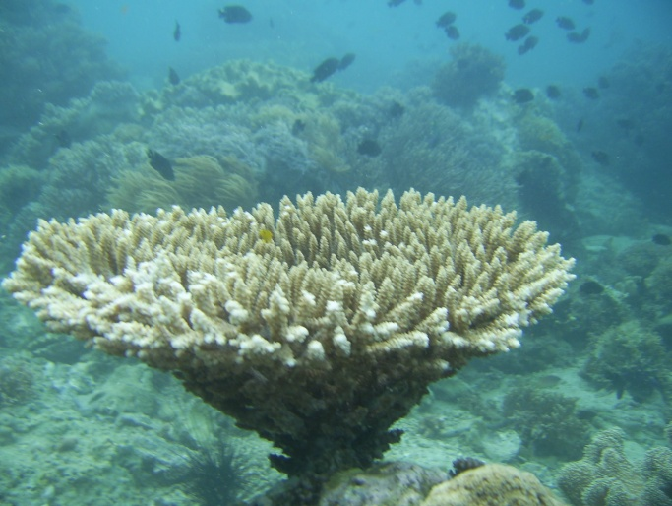

A coral reef specie that can be found in the Marine Sanctuary in Maonon, Ligao City